H.T No
Regulations:
A20

Sreenidhi Institute of Science and Technology
(An Autonomous Institution)
Code No: 8AC42 Date: 13-Sept-2021 (FN)

B.Tech I-Year II- Semester External Examination, Sept-2021 (Regular)
ELECTRICAL CIRCUITS & NETWORKS ANALYSIS (ECE)

Time: 3 Hours Max.Marks:70

Note: a) No additional answer sheets will be provided.
b) All sub-parts of a question must be answered at one place only, otherwise it will not be valued.
c) Missing data can be assumed suitably.

ANSWER ANY 5 OUT OF 8 QUESTIONS. EACH QUESTION CARRIES 14 MARKS.

Bloom's Cognitive Levels of Learning (BCLL)

Remember | L1 | Apply | L3 | Evaluate | L5
Understand | L2 | Analyze | L4 | Create | L6

 |  |  | BCLL | CO(s) | Marks
1. | a) | Explain super mesh and super node analysis by taking any example. | L3 | CO1 | [7M]
 | b) | Find the equivalent resistance between the terminals A and B by using star-delta transformation.  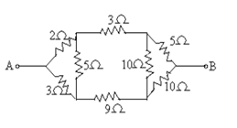 | L5 | CO1 | [7M]
2. | a) | Obtain bandwidth for parallel resonant circuit. | L3 | CO2 | [7M]
 | b) | Explain Steady State analysis of R-L series circuit with sinusoidal excitation. | L3 | CO2 | [7M]
3. | a) | Derive an expression for equivalent inductance when two coupled coils are connected in parallel opposing. | L4 | CO3 | [7M]
 | b) | A cast steel electromagnet has an air gap of length 2mm and an iron path of length 20cm. Find the MMF needed to produce a flux density of 0.6T in the gap. The Relative Permeability of steel is 1000. | L4 | CO3 | [7M]
4. | a) | For the circuit shown below find the current through load resistor R_{L} by using Milliman’s theorem.  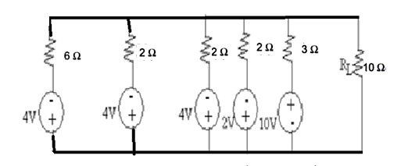 | L5 | CO4 | [7M]
 | b) | State and explain Thevenin’s theorem. | L2 | CO4 | [7M]
5. | a) | Obtain Y-parameters for the circuit given below.  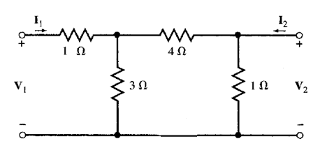 | L4 | CO5 | [7M]
 | b) | A typical two port network is characterized by the following equations  2V₁ + 4I₂ = I₁  V₂ + 6V₁ =8I₂  Determine the values of Z₂₁, h₁₂, Y₁₂ parameters. | L4 | CO5 | [7M]
6. | a) | Derive an expression for transient response of R-L series circuit with DC excitation using laplace transform method. | L4 | CO6 | [7M]
 | b) | Explain initial and final conditions for capacitor in a network. | L3 | CO6 | [7M]
7. | a) | Explain dependent and independent sources. | L2 | CO1 | [5M]
 | b) | Define quality factor and bandwidth. | L2 | CO2 | [5M]
 | c) | Derive the expression for coefficient of coupling. | L4 | CO3 | [4M]
8. | a) | State and explain maximum power transfer theorem. | L3 | CO4 | [5M]
 | b) | Obtain the h-parameters in terms of Y-parameters. | L4 | CO5 | [5M]
 | c) | Obtain the time constant for a series R-L circuit having R = 3Ω and L= 10H while a DC voltage of 100V is applied. | L3 | CO6 | [4M]

-- 00 -- 00 –

